# Education

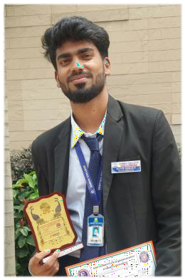

|  |  |  |
| --- | --- | --- |
| SSLC : |  | (2016-2017) |
| **CAMBRIDGE ENGLISH HIGH SCHOOL** | **-** | **82.24%** |
| PUC : **PCMB** |  | (2017-2019) |
| **VIDYANIDHI INDEPENDENT PU COLLEGE** | **-** | **67 %** |
| UG: **BCA(Bachelor of Computer Application)** |  | (2019-2022) |
| **SINDHI COLLEGE (Bangalore)** | **-** | **8 CGPA** |

**NABEELA ZAINAB**

**BCA (UG)**

# TECHNICAL SKIILS

**Information**

* Age:22
* Gender: Female
* **LANGUAGES KNOWN**: HTML, CSS, JAVA
* **ADDITIONAL SKILLS:** MICROSOFT EXCEL, MICROSOFT MICROSOFT POWERPOINT
* **DATABASE SYSTEM:** MySQL
* **OPERATING SYSTEM:** WINDOWS

WORD,

* Birthday:27/03/2000
* Location: Bangalore
* Mob :9986848669
* [Mail:nabeelazainab234@gmail.com](mailto:sujitvskumar8@gmail.com)

# Hobbies



* **ONGOING ADD-ON COURSE:**  Excel r solutions(selenium testing)

# Volunteer

* NSS Volunteer(2019-2022)
* Registration volunteer in College fest (2022)
* Class representative(2021-2022)

 

* + Crafting
  + Drawing & Sketching
  + Cooking and Baking
  + Designing cloths
  + Acting
  + Playing badminton

# Certificates and Achievement

* + Python : Sindhi College
  + Short film making : Inter-College(National level)

# Projects

* + Online examination system
  + Torrent Database